Using IoT to simulate a car parking bay and provide real time updates via an app based on external factors.

# Project Initiation Document

## Author: Tarikh Chouhan - w1481217

## Supervisor: Dimitris Dracopoulos

**General Scope of Project**

Finding a car parking bay can be very frustrating to drivers. As a result of this frustration, drivers tend to park illegally and end up having to pay a penalty/fine. Local councils are generating massive amounts of revenue by handing out parking fines. The following statistics paint a picture on how significant the car parking industry is:

|  |  |  |  |  |  |
| --- | --- | --- | --- | --- | --- |
| Surplus in £(millions) made in parking fines per local council [1] | | | | | |
| Local authority | **2010/11** | **2011/12** | **2012/13** | **2013/14** | **2014/15** |
| Westminster | 38.2 | 41.6 | 39.7 | 51 | 46.4 |
| Kensington & Chelsea | 21.1 | 28.1 | 30.4 | 33.5 | 33 |
| Camden | 21.1 | 25 | 23.5 | 24.9 | 24.5 |
| Hammersmith & Fulham | 16.6 | 19.5 | 19.4 | 23 | 23.8 |
| Wandsworth | 14.4 | 16.1 | 15.9 | 19.7 | 20.4 |
| Brighton & Hove UA | 12.7 | 14.4 | 16.3 | 18.1 | 18.6 |
| Haringey | 3.3 | 5.3 | 5.2 | 5.7 | 16.1 |
| Islington | 5.6 | 10.9 | 8.2 | 10.4 | 13.7 |
| Nottingham City UA | 3.7 | 3.3 | 11.8 | 12.1 | 13.3 |
| Hackney | 4.7 | 5.9 | 7.8 | 8.2 | 10.8 |
| Brent | 3.9 | 2.7 | 2.7 | 8.3 | 10.5 |
| Tower Hamlets | 6 | 5.8 | 7 | 8.3 | 10 |
| Birmingham | 5.1 | 5.5 | 6.9 | 7.8 | 9.7 |
| Lambeth | 7 | 5.8 | 12 | 7.2 | 9.7 |
| Milton Keynes UA | 6 | 6.6 | 6.7 | 8.2 | 9 |
| Cornwall UA | 8.2 | 7.9 | 8.1 | 8 | 8.7 |
| Manchester | 1.9 | 6.3 | 8.8 | 8 | 7.9 |
| Hounslow | 6 | 7.3 | 6.4 | 7.8 | 7.7 |
| Newham | 3.9 | 7.3 | 8.2 | 7.2 | 7.3 |
| Merton | 4.4 | 5.7 | 6.9 | 7 | 7.2 |

The aim of this project is to help solve an on-going problem most car drivers face daily; finding an available bay to park in. This project will aid and help car drivers find a car parking bay that they’ll be able to park in without driving further than necessary, searching for an available space to park in.

This will be achieved by creating a sensor (using an Arduino Uno) that will record the data from an ultrasonic sensor, GPS module and thermistor module. Once the modules acknowledge a drastic change in these two external factors, the results will be shown to the user via an app hence indicating whether or not the bay is vacant or occupied. As well as that, the app will learn how the data correlates to the bay being vacant or occupied, essentially machine learning. This will be achieved by implementing the concept of neural network and using the logistic algorithm. The reason for using the logistic algorithm is because it is typically used to answer ‘Yes/No` questions and this fits my situation as there are only 2 answers in my context; the parking bay is either occupied or vacant. By implementing this feature, the app will be able to predict whether or not the bay is being used and will come in handy if for some reason the sensor cannot fulfil its purpose (e.g. if there are networking issues, wiring issues, external factors such as rain etc.).

Upon preliminary research, it shows that this type of concept does exist but is still in its infancy. An example of this is Google Maps. In their latest update to the app (August 2017), they are using historic data with machine learning to predict the availability of car parking bays[2]. Whilst this is a step in the right direction to solving the problem described, it is not as accurate as having a physical sensor embedded to the parking bays. As the world progresses further in technology, more and more devices are being connected to the internet, the concept of IoT (internet of things) will be greatly beneficial here and will outperform the use of machine learning. With this in mind, I believe my project will perform greatly as it has the concept of IoT and will be able to serve its purpose with accurate results whilst fulfilling its requirements.

**Aims, Objectives and Requirements**

In order to successfully complete this project and have a live working sensor and app, there will be strict aims and objectives that will have to be met set against the listed requirements. Failure to do so would result in the sensor and/or app not performing as intended or worse, not performing at all. In order to prioritise my aims and goals, the MoSCoW principle will be used. The MoSCoW principle is widely used as a prioritization technique and is heavily used in field of business analysis, project management and software development. The capital letters in the term ‘MoSCoW’ is an acronym coming from the first letter of each prioritization groups:

M – Must

S – Should

C – Could

W - Would

Firstly, my main aim is to build the sensor as this project resolves around solving the described problem using the concept of IoT. The sensor must take readings from external factors such as temperature and distance from an object. This will be achieved by acquiring components that will be able to record these factors; thermistor to measure the temperature and an ultrasonic sensor to measure distance. The reason for recording external factors such as temperature and distance is because this will indicate that a car has been driven on top of the sensor; effectively indicating that the bay is now being occupied. The base of the car will be hot since the engine will have been running, and so there will be a drastic temperature change to the sensor as well as the base of the car being close to the sensor, effectively being detected by the ultrasonic sensor.

Moreover, in order for the sensor to be connected to the internet and be a part of the IoT category, it must be able to send and receive data over some form of network protocol. Ideally, this will be in HTTP as this form of protocol is widely used to send and receive data. In order to achieve this, a microcontroller (the sensor) will be used and will be capable of connecting to WiFi by wiring a wifi module to it. The sensor will register external changes every 30 seconds and send the data to a server.

Furthermore, the user must be able to know whether the parking bay is being occupied or not. An effective way of showing this will be from an app. This will be achieved by incorporating the data from the sensor with the Google Maps API. By using Google Maps API, I will be able to show the location of the sensor to the user as well as the status of the parking bay. As of now, the app will be an android app.

Even more, a server must be created so that the sensor and app will be able to communicate together. An effective way of communicating to this server will be over the REST architecture. REST is widely used in servers and web services as it caters a wide array of different formats for the response, i.e. JSON, CSV, XML etc. REST is widely chosen over SOAP as parsing through XML and the friction between Javascript and XML can cause issues[3]. Also, the structure of the JSON response should resemble the following:

{

“_id” : string,

“longitude” : string,

“latitude”: string,

timeDateOfUsage :

[

“timeAndDate”,

“statusOfBay”

]

}

The above JSON is satisfactory for the app as it will receive the response in a fashion where it can easily iterate through the core records (i.e. the time and date of the parking bay is vacant/occupied). As the sensor posts the data to the server, the server will post to the database in which it will concatenate the already stored records with the new data hence having a trail of records of when the parking bay is vacant/occupied. This will be valuable when implementing the logistic machine learning algorithm in my project as all the data will be in a list as opposed to having its own record in the database hence it will be easier to collect it.

The above were the main aims and objectives of this project, without them, the project would be unable to perform and fulfil its main requirements which is essentially to notify the user if a car parking bay is available or not. The following aims fall under the ‘should’ category:

Firstly, the app should be able to predict when a parking bay will be in use or not depending on the data already collected by the sensor. This will be achieved by implementing neural network. The inputs into the network will be date and time and the output should be 1 or 0, occupied or vacant respectively.

Secondly, the database being used to store the data from the sensor should be in a NoSQL database. The reason behind this choice is due to the fact that noSQL is known for its speed as it can be horizontally scaled. This is means that the more database servers you have in the server pool, the faster it is to perform operations rather than adding more power (i.e. powerful hardware) to the servers; which is known as vertical scaling. I do plan on taking this project and developing it to a commercial grade hence it is important to think about the overall big picture as there will theoretically be thousands of sensors writing to the databases.

Moreover, I have gathered another requirement through the use of prototyping my project. I have built a prototype of the sensor using the arduino uno and it was found out that having a GPS module is not viable. This is because, the GPS module needs around 10 minutes to triangulate the position using satellites and also the GPS was very sensitive hence it needed to be outdoors with clear sky. This variable is beyond my reach as it is uncommon to have clear blue skies in the UK as well as going and conducting tests outdoors. One way of overcoming this problem is by using a stronger GPS module but that would cost a lot of money as well as the module not being powered on simply by using the arduino as a power supply. For this reason, a GPS coordinate will be hardcoded to give the impression that a GPS module is fit in the sensor.

Below is an overview of my aims and objectives.

|  |  |  |
| --- | --- | --- |
| **MoSCoW Category** | **Aim** | **How will this be achieved** |
| Must | Building the sensor | Using an Arduino Uno and gathering the write components, wiring them and writing the source code. |
| Must | Sensor must be able to connect to wifi | By a connecting a wifi module to the microcontroller |
| Must | Sensor must be able to connect to server using HTTP | Using the Arduino libraries for HTTP connection |
| Must | App should show results of the sensor | The app will communicate with the senor, gather the data and display them using on a map using Google Maps API |
| Must | Server should communicate using REST | Using a server capable of REST methods (GET, POST, etc) and return response in JSON format. |
| Should | App should predict when a parking bay will be taken. | By implementing neural network. |
| Should | Use a non-tabular relational database | Use a NoSQL database such as MongoDB |
| Would | Implement a feature where user enters address and app will tell if there is a parking bay spot available | To show more than one parking bay availability, I’d have to create a sensor for each parking bay which is not in the scope of this project. |

**Project Deliverables**

The majority of this project is split into 3 major parts; Sensor, Web Server and App. By focusing on each part individually, I’ll be able to split and prioritise my time accordingly and maximise my efforts as I will be solely focused on the part I am currently working on.

There are many different styles and approaches when it comes to planning. There is the ‘Waterfall’ method which is a sequential approach where you focus one phase, get it done, and move onto the next phase. A general waterfall model will have 4-6 phases which include; requirements, design, implementation and maintenance.

Another method is the SCRUM method which is popular amongst the tech industry. SCRUM is a subset of the Agile methodology which is based on iterative development. SCRUMs core concept is the use of development cycles called Sprints which allows one to dynamically adapt to changes whether it be from issues in code or requirements changing. Furthermore, issues/tasks are placed in Sprints and within the duration of the Sprint, one aims to get everything finished. Upon completion of the Sprint, there is a Sprint planning in which issues and tasks are taken from a backlog and placed into the current Sprint. By having this ability, this is what makes SCRUM more dynamic and adaptable to change.

Based on these methodologies, the most sensible approach would be to split the project into 3 parts; sensor, web server and App, and focus on them individually as well as each part having their own methodology. Since the sensor won’t be subject to a lot of changes, it would be advisable to go to the waterfall method. The reason for this is because the waterfall method is useful on clear and concise projects. When a phase is completed, there is necessarily no need to back track on the phases prior. Because of this concept, this makes it advisable to use the waterfall method when constructing and coding the sensor as once it is built and working, there will be no need to go back. However, because the web server and app is more active and subject to changes, tackling these parts of the project will be done in an agile manner. Mainly in a SCRUM manner as it will give more time to adapt to any changes.

Furthermore, Git will be used throughout the project as it is a widely used version control system and is very powerful even when using the basic features of it. Git will aid me as I’ll be committing small segments of working code at a time to ensure nothing goes wrong. If something does go awry, I can always revert to a previous commit.

Even more, I will need to spend time researching, designing, implementing and testing each of the 3 parts to the project. This will be done within the relevant timeframes as I split my project into 3 parts; the sensor, web server and the app.

Below is an estimate on how I aim to achieve this using a Gantt chart and also on how I aim to priorities my time and achieve my project deliverables. A Gantt chart is useful as it shows a lot of information visually and is easy to understand and see the progress of the project.

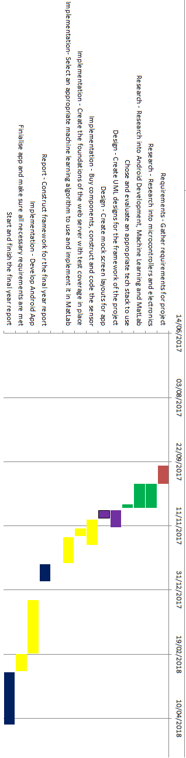

As well as that, I aim to create the app by planning the structure of it using UML diagrams as this will provide a solid understanding on how all the components will interact with each other. Below are the few examples on how I will code certain parts of the project:

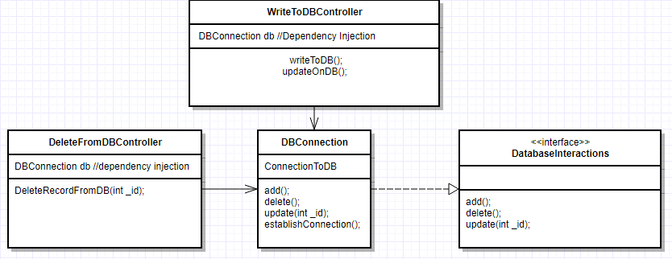

As you can see from the above UML, I will be using an interface. This interface will be needed as it will loosely couple the class that will do all the logic regarding writing and deleting the database. Furthermore, it is good to loosely couple classes as it makes your code more dynamic and adaptable to changes. I will also be using dependency injection in the Controller classes that require a `DBConnection` object as this will make testing for more easier as I will be able to mock the object.

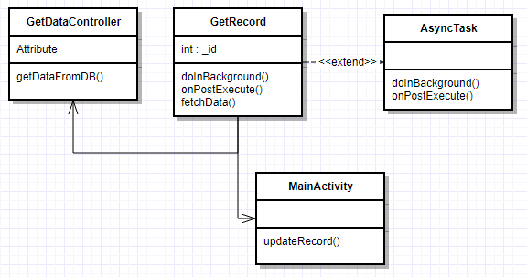

The above scenario is getting the data from the server and publishing it on the app’s screen. As per android policy, any heavy computation should be placed in a class that extends AsyncTask as it is forbidden to run these codes on the main thread of the application as it will crash the app. Thus, the mainActivity in this example will call the GetRecords’ fetchData() which will be ran on another thread created by AsyncTask. fetchData() will be calling the a method to the server which will return the result, ultimately being passed to the MainActivity’s screen.

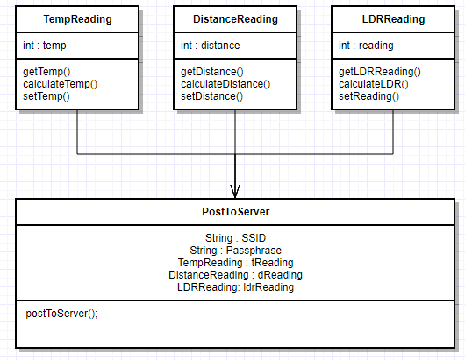

The above diagram shows how I plan on structuring the sensors code. As you can see, I will have 3 classes. Each of these classes will calculate their respective readings. The main class, PostToServer, will then get the readings using the getter methods and then send a HTTP post method to the server.

**Risks**

As with all projects, there are risks associated with it and these risks can vary from different types of categories whether it be a technical risk, or a risk stemming from the requirements. These can cause problems whilst undertaking this project therefore it is wise to be aware of any risks in the scope of this project and outline how they will be tackled. By tackling them early on, it’ll prevent the problem from turning into a bigger issue as this project goes on.

Knowledge on electronics

Wiring and coding the sensor requires some knowledge of electronics. Without knowing the basic fundamentals on how electronics work in a circuit, creating the sensor will be an issue. Hence it is advisable that I will need to research about the topic. The best way to get familiar with the microcontroller I will be using, an Arduino Uno, is to go to the official Arduino website and read their documentation over there as well as undertake some of their exercises. Furthermore, the website circuits.io from Autodesk has an online Arduino simulator which you can use to practise building circuits. This will be highly useful as it will tell me early on whether or not my circuit will be feasible or not.

Knowledge on Android

I have an understanding of the basics of the Android framework and how android apps are built but since I will be planning on using machine learning and optimising my app, I will need to research deeper into android app development and understand the best approach to achieve this goal. A starting point would be to look at the official Android development guide from Google as this will be packed with useful information. Furthermore, there is a vast amount of android development tutorials on YouTube, Udemy, Udacity etc. From a physical publication perspective, the book ‘Head First Android Development: A Brain Friendly Guide’ will be useful in understanding the core concepts of android development and also it has a lot of good ratings.

Knowledge in Machine Learning

Machine learning is a topic that I don’t necessarily have enough knowledge on. In order to implement one of my requirements, I will need to understand the core foundation of machine learning, more precisely neural networking. I will be reading books that introduces the foundation of machine learning as well as reading articles and watching videos that will explain it in a visual manner. As well as that, I will be undertaking some crash courses. In order to implement the machine learning functionality into the app, I will need to prioritise more time for more research and getting a better understanding of it.

Faulty hardware/software

As with every circuit, there is a chance that there may be a wire that becomes disconnected with daily usage of the device and as a result the device stops working or maybe through extensive usage, the device gets too hot and the solder being used to connect a wire to the circuit board melts away causes the device to stop. There are a lot of small things that could go wrong which will heavily impact on the project. To overcome this, I will be testing the components using a voltmeter to determine if they are in working condition. Furthermore, I will buy twice the quantity needed just in case something happens with the initial component and stops working.

In regards to the software aspect, it is more of logical errors and bugs that will cause a lot of the problems. This will be fixed by following a TDD (test driven development) approach as this is sort of development style is heavily used in the industry as it guarantees that your code is in working condition since it shows the code has been revolved around the unit tests rather than the unit tests revolving around the code. Furthermore, by using Git, it will make this project more manageable as I will be able to revert back to previous versions that worked if something goes wrong whilst implementing a feature on the current version.

1. RAC Foundation, December 2015, Council parking 'profits' up again in England, Available at: http://www.racfoundation.org/media-centre/council-parking-profits-up-again-in-england-2014-15
2. Google Blogs, August 2017, Put it in park with new features in Google Maps, Available at:https://www.blog.google/products/maps/put-it-park-new-features-google-maps/

  
3. John Mueller, January 2013, Understanding SOAP and REST Basics And Difference, Available at: https://blog.smartbear.com/apis/understanding-soap-and-rest-basics/